LAB Logbook

Lab 1:

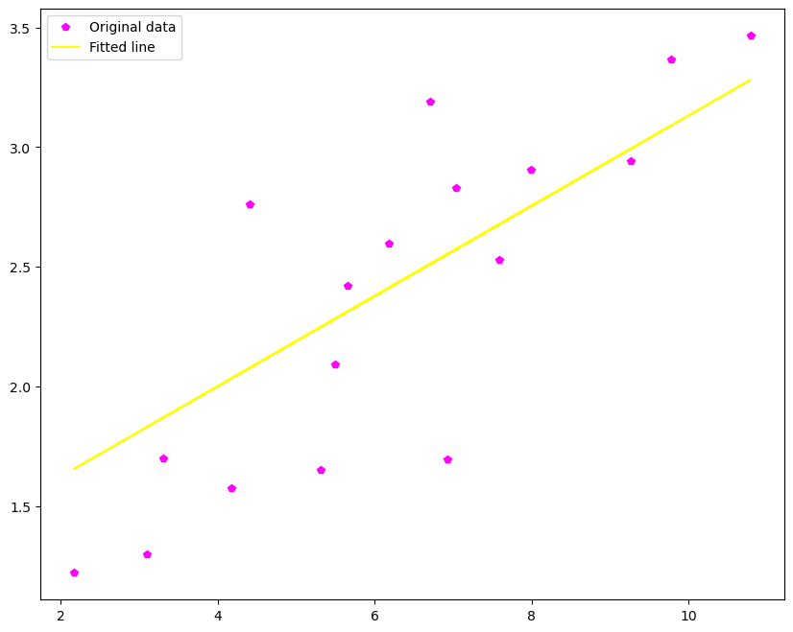

Lab 2

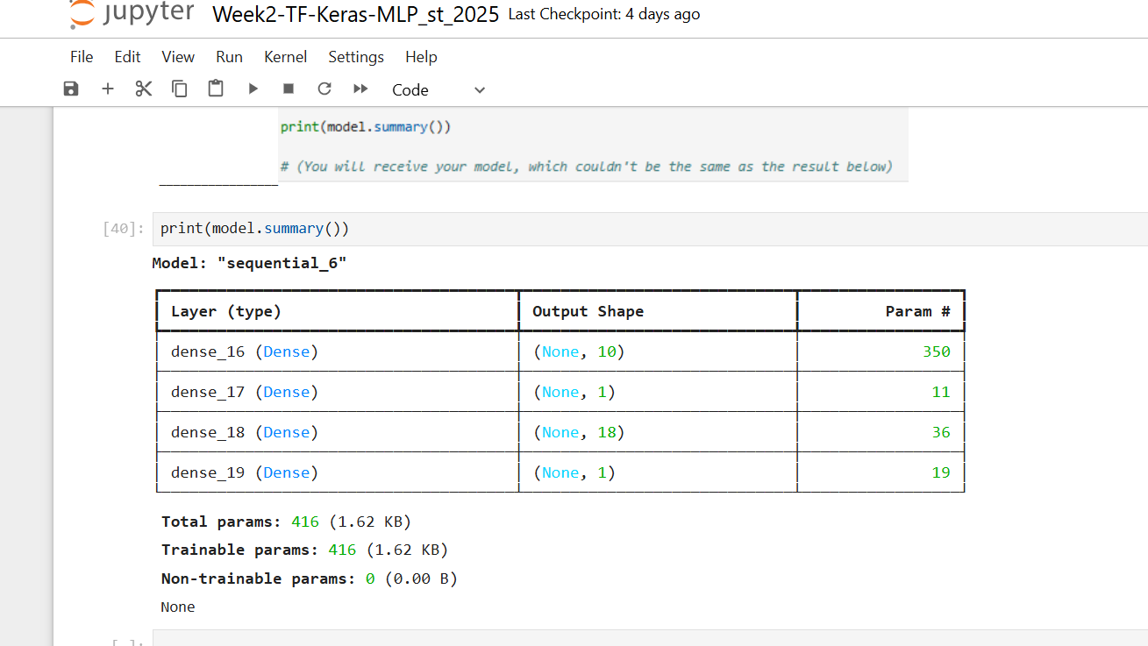

Accuracy: “0.862”

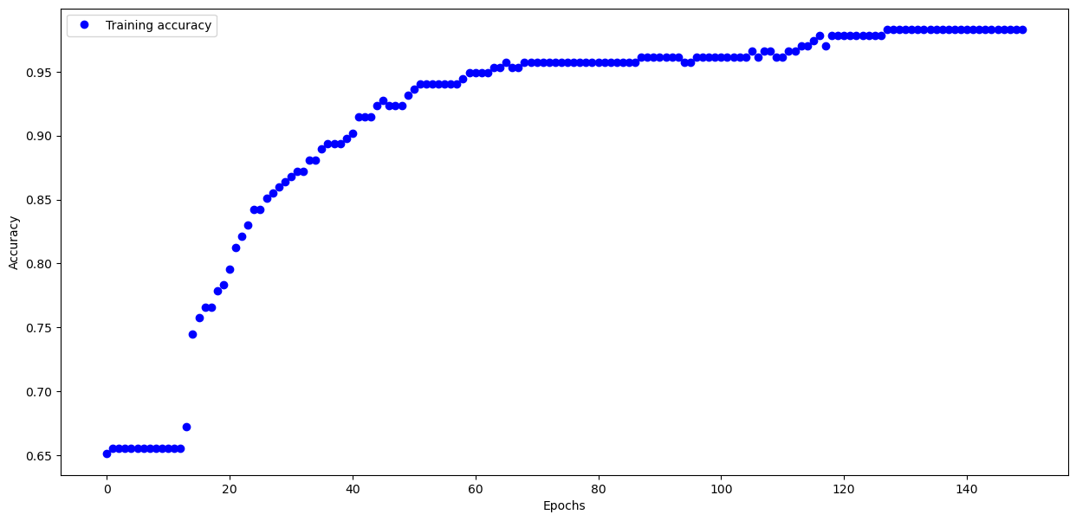

Lab 3

Test accuracy: 0.8953999876976013

Model summary:

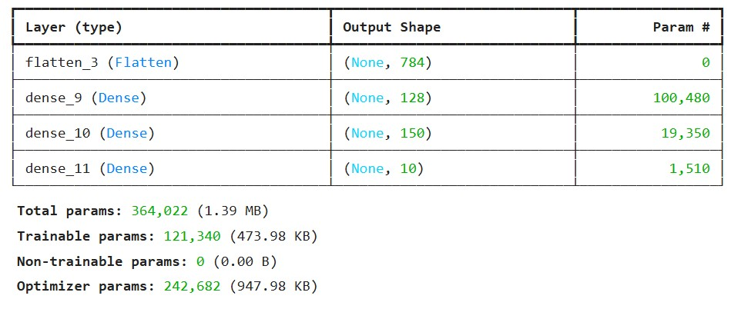

Lab 4

absolute prediction error = 318662.0 $

relative prediction error = 143.60612888688598 %

Lab 5:

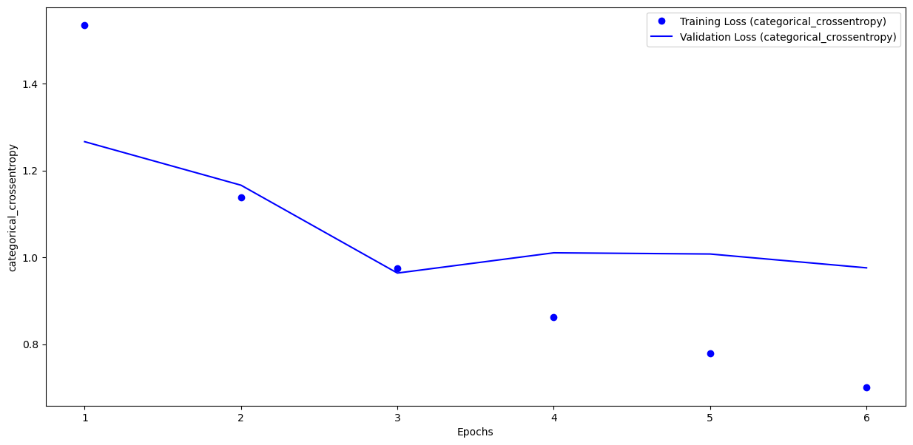

optimal number of epochs**: 06**

Lab 6:

Low loss is found in Epoch 13/30 ==== val_loss: 0.0011

**optimal number of epochs**  == 14

Lab 7

Lab 8

Lab 9

Lab 10

Lab 11

Lab 12